A486-AM,N-NW-Tlingit-Sun Crest-Blue­_eyed-**Wood and Paint-Late 20th Century** 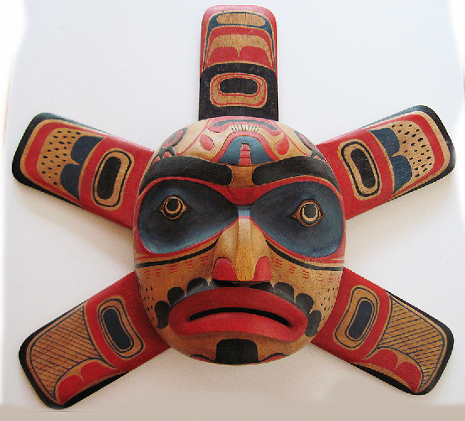

**Fig. 1.** Tlingit-Sun Crest-Blue­_eyed-**Wood and Paint-Late 20th Century**

**Case no.: 8**

**Accession Number: A486**

**Formal Label:** Tlingit-Sun Crest-Blue­_eyed-**Wood and Paint-Late 20th Century**

**Display Description:**

Meaning:  Sun radiates sunlight, warmth, and healing powers. This blue-eyed version of a Sun Crest may indicate diminished (blue) sunlight made by a partial or full solar eclipse. The red-eyed version of a Sun Crest is presumed to indicate regular sunlight.

**Date or Time Horizon:** late 20th century

**Geographical Area:** southern Alaska

**Map, GPS coordinates:**

The Sun Crest is “owned” by three Tlingit tribes

1). SHTAX’HÉEN KWÁAN: Wrangell Bitter Water Tribe, Raven Moiety, Kiks.ádi Gagaan Hít (Sun House), at Wrangell, AK: 56º28'15" N 132º22'36" W.

2). SHEEY AT‘IKÁ (a.k.a. SHEET’KÁ) KWÁAN: Sitka Outside Edge of a Branch Tribe, Raven Moiety, Gagaan Hít (Sun House), at Sitka, AK: 57º03'11" N 135º19'48" W.

3). JILKOOT KWÁAN: Haines Chilkoot Tribe, Wolf/Eagle Moiety, Shangukeidí Kaawdliyaayi Hít (House Lowered from the Sun) at Haines, AK: 59°08'21.21" N -135°00'0.00" W.

LC Classification: E99.T6

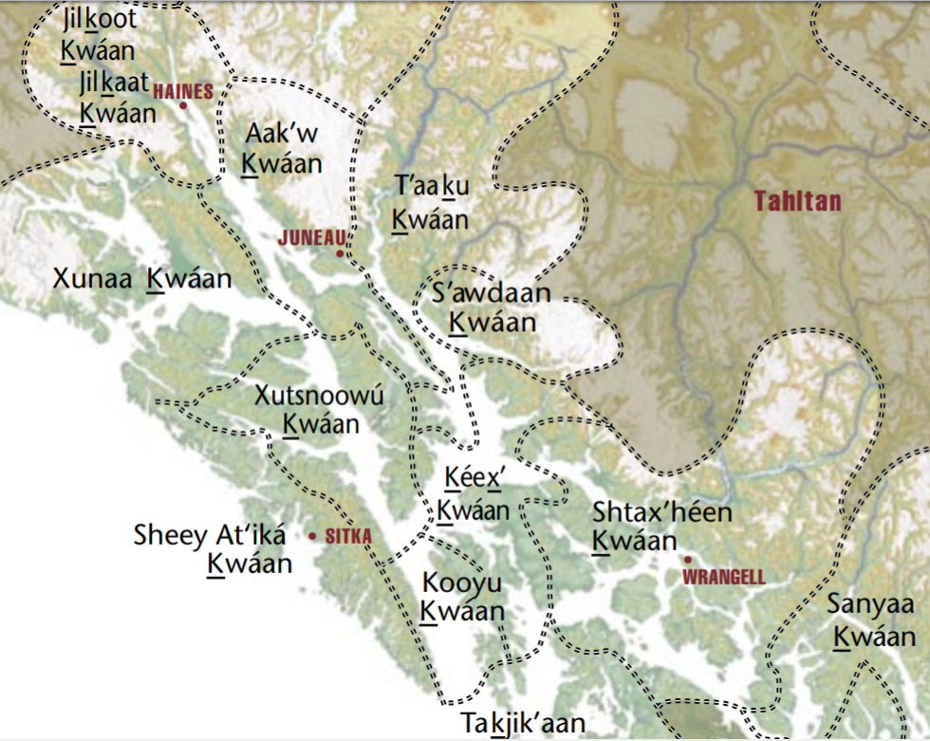

Fig. 2 Map of Sun Crest Tribal Locations, Pacific Northwest. From http://www.cherrygallery.com/journal/wp-content/uploads/2015/03/Tlingitgroups.jpg

**Cultural Affiliation:** Tlingit

**Media:** cedar; red black, dark blue paint.

**Dimensions: H** 146.01 cm, 5.75 in; W 146.01 cm, 5.75 in

**Weight: 54 gm, 1 lb 7/8 oz**

**Condition: original.**

**Provenance:** artist

**Discussion:**

Legend: Long ago Raven was pure white, like fresh snow. He lived high in the mountains. Below in the valley “the People” were camped in wigwams. There an avaricious Chief coveted elaborately carved cedar boxes in his wigwam, which confined Stars, Moon, and Sun under lock and key. The only light Raven could see from his high mountain nest came from “The People’s” campfires. Raven flew down to the valley following these campfires and found the Chief’s wigwam. Quickly Raven transformed himself into the shape of the Chief’s baby grandson and hid the baby out of sight under some blankets. Then Raven cried and cried like a human baby for the beautiful boxes to be opened. Out of desperation the Chief opened the boxes one by one. He first opened the one with Stars and released starlight. Sky glimmered with millions of tiny stars in the night but Day was still dark. Then he opened the one with Moon and released moonlight. Now Night was brighter when Moon was full, but then Stars were outshone. During the daytime when Moon was full there was an eerie glow of Moon in the sky. But, Day was still dark. At night only when Moon was darker were Stars more visible. Things were still not right. So Raven kept crying. Finally, the Chief slowly opened the cedar box with Sun. Raven had been able to maintain his shape as a human baby until this point, but it had been difficult because he wanted his raven-shape back.

Then Sun Chief fully opened the box with Sun and Earth was flooded with sunlight. Raven was so joyful he stopped crying like a baby and in a split second his shape transformed into a raven. Sun Chief immediately recognized him and was furious with his deceit. First, he found his baby grandson under the blankets. Then, he captured Raven who could not fly out of the wigwam because the flap was tied shut. The Chief crammed him into the box that had held Sun. While the Chief was busy with his grandson and untied the flap of the wigwam to take the baby into the sunlight, Raven was able to silently squeeze himself through the small smoke-hole at the top of the cedar box with much difficulty. He was able to escape through the opened wigwam door, and now he could fly to his high mountain home in the light of the Sun.

That is why ravens are now black-as-a-smoke-hole instead of pure white like fresh snow, and that’s why they like to live high in the mountains so they can keep watch on “the People” below.

Up above, the Sun was also so happy he smiled and he displayed Himself as a Crest in the sky with five beautiful fiery red rays of light, so they could shine on all the continents of earth.

Then one day something unusual happened. Moon came between Sun and Earth. Sun’s light was blocked as Moon moved past Him. In dejection, Sun’s light hitting Earth was now blue instead of fiery red. Sun was dejected. As he frowned his mouth was turned downward.

That is why on this Sun Crest Sun’s eyes are blue and his mouth is turned down.

(retold by R. J. Coffman, Jr. 2017)

References:

Boas, Franz, ed. 1911 and 1922. Handbook of American Indian Languages. BAE Bulletin 40, parts 1 and 2. Washington: GPO. 2 vols

Durlach, Theresa. 1928. *The relationship systems of the Tlingit, Haida, and Tsimshian*. New York: American Ethnological Society, G.E. Stechert and Co., Agents, 1928.

Swanton, John Reed. 1904-1905. “Social condition, beliefs, and linguistic relationship of the Tlingit Indians.” In Bureau of American Ethnology, *26th Annual Report*. Washington, D.C.: U.S. GPO.

HRAF-Human Relations Area Files (NA12)

|  |  |  |
| --- | --- | --- |
| Ackerman, Maria, 1927-. | [Tlingit stories](http://ehrafworldcultures.yale.edu/ehrafe/citation.do?method=citation&forward=browseCulturesFullContext&col=collection(%27/eHRAF/ethnography/NorthAmer/NA12%27)&docId=na12-021&tocOffsetId=tocPubInfoP) | 1975 |
| Dauenhauer, Richard, 1942-. | [Text and context of Tlingit oral tradition](http://ehrafworldcultures.yale.edu/ehrafe/citation.do?method=citation&forward=browseCulturesFullContext&col=collection(%27/eHRAF/ethnography/NorthAmer/NA12%27)&docId=na12-028&tocOffsetId=tocPubInfoP) | 1976 |
| De Laguna, Frederica, 1906-. | [The story of a Tlingit community: a problem in the relationship between archaeological, ethnological and historical methods](http://ehrafworldcultures.yale.edu/ehrafe/citation.do?method=citation&forward=browseCulturesFullContext&col=collection(%27/eHRAF/ethnography/NorthAmer/NA12%27)&docId=na12-017&tocOffsetId=tocPubInfoP) | 1960 |
| De Laguna, Frederica, 1906-. | [Under Mount Saint Elias: the history and culture of the Yakutat Tlingit](http://ehrafworldcultures.yale.edu/ehrafe/citation.do?method=citation&forward=browseCulturesFullContext&col=collection(%27/eHRAF/ethnography/NorthAmer/NA12%27)&docId=na12-020&tocOffsetId=tocPubInfoP) | 1972 |
| De Laguna, Frederica, 1906. | [Some problems in the relationship between Tlingit archaeology and ethnology](http://ehrafworldcultures.yale.edu/ehrafe/citation.do?method=citation&forward=browseCulturesFullContext&col=collection(%27/eHRAF/ethnography/NorthAmer/NA12%27)&docId=na12-015&tocOffsetId=tocPubInfoP) | 1953 |
| Emmons, George Thornton, 1852-. | [The Tlingit Indians](http://ehrafworldcultures.yale.edu/ehrafe/citation.do?method=citation&forward=browseCulturesFullContext&col=collection(%27/eHRAF/ethnography/NorthAmer/NA12%27)&docId=na12-031&tocOffsetId=tocPubInfoP) | 1991 |
| Garfield, Viola Edmundson, 1899-. | [Historical aspects of Tlingit clans in Angoon, Alaska](http://ehrafworldcultures.yale.edu/ehrafe/citation.do?method=citation&forward=browseCulturesFullContext&col=collection(%27/eHRAF/ethnography/NorthAmer/NA12%27)&docId=na12-011&tocOffsetId=tocPubInfoP) | 1947 |
| Jonaitis, Aldona, 1948-. | [Art of the northern Tlingit](http://ehrafworldcultures.yale.edu/ehrafe/citation.do?method=citation&forward=browseCulturesFullContext&col=collection(%27/eHRAF/ethnography/NorthAmer/NA12%27)&docId=na12-022&tocOffsetId=tocPubInfoP) | 1986 |
| Jones, Livingston French, 1865-1928. | [A study of the Thlingets of Alaska](http://ehrafworldcultures.yale.edu/ehrafe/citation.do?method=citation&forward=browseCulturesFullContext&col=collection(%27/eHRAF/ethnography/NorthAmer/NA12%27)&docId=na12-006&tocOffsetId=tocPubInfoP) | 1914 |
| Kan, Sergei. | [Symbolic immortality: the Tlingit potlatch of the nineteenth century](http://ehrafworldcultures.yale.edu/ehrafe/citation.do?method=citation&forward=browseCulturesFullContext&col=collection(%27/eHRAF/ethnography/NorthAmer/NA12%27)&docId=na12-032&tocOffsetId=tocPubInfoP) | 1989 |
| Klein, Laura F. (Frances), 1946-. | [Tlingit women and town politics](http://ehrafworldcultures.yale.edu/ehrafe/citation.do?method=citation&forward=browseCulturesFullContext&col=collection(%27/eHRAF/ethnography/NorthAmer/NA12%27)&docId=na12-025&tocOffsetId=tocPubInfoP) | 1975 |
| Knapp, Frances. | [The Thlinkets of southeastern Alaska](http://ehrafworldcultures.yale.edu/ehrafe/citation.do?method=citation&forward=browseCulturesFullContext&col=collection(%27/eHRAF/ethnography/NorthAmer/NA12%27)&docId=na12-009&tocOffsetId=tocPubInfoP) | 1896 |
| Krause, Aurel, 1848-. | [The Tlingit Indians: results of a trip to the northwest coast of America and the Bering Straits](http://ehrafworldcultures.yale.edu/ehrafe/citation.do?method=citation&forward=browseCulturesFullContext&col=collection(%27/eHRAF/ethnography/NorthAmer/NA12%27)&docId=na12-001&tocOffsetId=tocPubInfoP) | 1956 |
| McClellan, Catherine. | [The Inland Tlingit](http://ehrafworldcultures.yale.edu/ehrafe/citation.do?method=citation&forward=browseCulturesFullContext&col=collection(%27/eHRAF/ethnography/NorthAmer/NA12%27)&docId=na12-014&tocOffsetId=tocPubInfoP) | 1953 |
| McClellan, Catherine. | [The interrelations of social structure with northern Tlingit ceremonialism](http://ehrafworldcultures.yale.edu/ehrafe/citation.do?method=citation&forward=browseCulturesFullContext&col=collection(%27/eHRAF/ethnography/NorthAmer/NA12%27)&docId=na12-016&tocOffsetId=tocPubInfoP) | 1954 |
| Oberg, Kalervo, 1901-1973. | [Crime and punishment in Tlingit society](http://ehrafworldcultures.yale.edu/ehrafe/citation.do?method=citation&forward=browseCulturesFullContext&col=collection(%27/eHRAF/ethnography/NorthAmer/NA12%27)&docId=na12-004&tocOffsetId=tocPubInfoP) | 1934 |
| Oberg, Kalervo, 1901-1973. | [The social economy of the Tlingit Indians](http://ehrafworldcultures.yale.edu/ehrafe/citation.do?method=citation&forward=browseCulturesFullContext&col=collection(%27/eHRAF/ethnography/NorthAmer/NA12%27)&docId=na12-018&tocOffsetId=tocPubInfoP) | [n.d] |
| Olson, Ronald L. (Ronald LeRoy), 1895-. | [Social structure and social life of the Tlingit in Alaska](http://ehrafworldcultures.yale.edu/ehrafe/citation.do?method=citation&forward=browseCulturesFullContext&col=collection(%27/eHRAF/ethnography/NorthAmer/NA12%27)&docId=na12-019&tocOffsetId=tocPubInfoP) | 1967 |
| Rathburn, Robert Richard, 1947-. | [Processes of Russian-Tlingit acculturation in southeastern Alaska](http://ehrafworldcultures.yale.edu/ehrafe/citation.do?method=citation&forward=browseCulturesFullContext&col=collection(%27/eHRAF/ethnography/NorthAmer/NA12%27)&docId=na12-026&tocOffsetId=tocPubInfoP) | 1976 |
| Sealaska Corporation. | ['Because we cherish you--': Sealaska elders speak to the future](http://ehrafworldcultures.yale.edu/ehrafe/citation.do?method=citation&forward=browseCulturesFullContext&col=collection(%27/eHRAF/ethnography/NorthAmer/NA12%27)&docId=na12-023&tocOffsetId=tocPubInfoP) | 1981 |
| Shotridge, Florence. | [The life of a Chilkat Indian girl](http://ehrafworldcultures.yale.edu/ehrafe/citation.do?method=citation&forward=browseCulturesFullContext&col=collection(%27/eHRAF/ethnography/NorthAmer/NA12%27)&docId=na12-013&tocOffsetId=tocPubInfoP) | 1913 |
| Shotridge, Louis. | [Chilkat houses](http://ehrafworldcultures.yale.edu/ehrafe/citation.do?method=citation&forward=browseCulturesFullContext&col=collection(%27/eHRAF/ethnography/NorthAmer/NA12%27)&docId=na12-012&tocOffsetId=tocPubInfoP) | 1913 |
| Swanton, John Reed, 1873-. | [Social condition, beliefs, and linguistic relationship of the Tlingit Indians](http://ehrafworldcultures.yale.edu/ehrafe/citation.do?method=citation&forward=browseCulturesFullContext&col=collection(%27/eHRAF/ethnography/NorthAmer/NA12%27)&docId=na12-010&tocOffsetId=tocPubInfoP) | 1904-1905 |
| Tollefson, Kenneth D. | [A structural change in Tlingit potlatching](http://ehrafworldcultures.yale.edu/ehrafe/citation.do?method=citation&forward=browseCulturesFullContext&col=collection(%27/eHRAF/ethnography/NorthAmer/NA12%27)&docId=na12-035&tocOffsetId=tocPubInfoP) | 1977 |
| Tollefson, Kenneth D. | [Culture summary: Tlingit](http://ehrafworldcultures.yale.edu/ehrafe/citation.do?method=citation&forward=browseCulturesFullContext&col=collection(%27/eHRAF/ethnography/NorthAmer/NA12%27)&docId=na12-000&tocOffsetId=tocPubInfoP) | 1997 |
| Tollefson, Kenneth D. | [From localized clans to regional corporation: the acculturation of the Tlingit](http://ehrafworldcultures.yale.edu/ehrafe/citation.do?method=citation&forward=browseCulturesFullContext&col=collection(%27/eHRAF/ethnography/NorthAmer/NA12%27)&docId=na12-034&tocOffsetId=tocPubInfoP) | 1978 |
| Tollefson, Kenneth D. | [Northwest Coast village adaptations: a case study](http://ehrafworldcultures.yale.edu/ehrafe/citation.do?method=citation&forward=browseCulturesFullContext&col=collection(%27/eHRAF/ethnography/NorthAmer/NA12%27)&docId=na12-036&tocOffsetId=tocPubInfoP) | 1982 |
| Tollefson, Kenneth D. | [Potlatching and political organization among the Northwest Coast Indians](http://ehrafworldcultures.yale.edu/ehrafe/citation.do?method=citation&forward=browseCulturesFullContext&col=collection(%27/eHRAF/ethnography/NorthAmer/NA12%27)&docId=na12-033&tocOffsetId=tocPubInfoP) | 1995 |